**Name: STEBIN BABU**

**Roll No: 44**

**Batch:B**

**Date: 01-04-2022**

**ADVANCED DBMS LAB**

**Experiment No.: 2**

**Aim**

To familiarize with selecting data from single table

**QUESTION**

1. List all data from table deposite

2. List all data from borrow

3. List all data from customer

4. List all data from branch

5. Give account no and amount of deposite

6. Give customer name and account no of depositors

7. Give name of customers

8. Give name of branches

9. Give name of borrows

10. Give names of customer living in city Nagpur

11. Give names of depositors having amount greater than 4000

12. Give account date of Anil

13. Give name of all branches located in Bombay

14. Give name of borrower having loan number l205

15. Give names of depositors having account at VRCE

16. Give names of all branched located in city Delhi

17. Give name of the customers who opened account date ‘1-12-96’

18. Give account no and deposit amount of customers having account opened between dates  ‘1-12-96’ and ‘1-5-96’

19. Give name of the city where branch KAROLBAGH is located

20. Give details of customer ANIL

**Procedure and Output Screenshot**

1. **DEPOSITE TABLE**

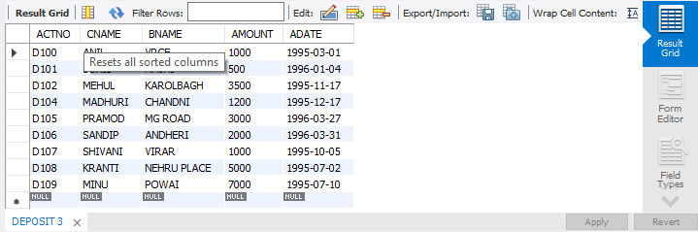

**2.BORROW TABLE**

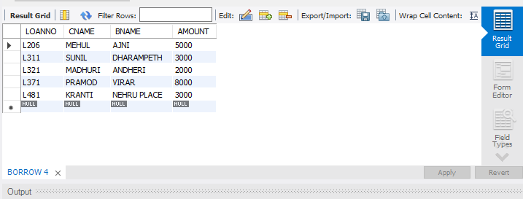

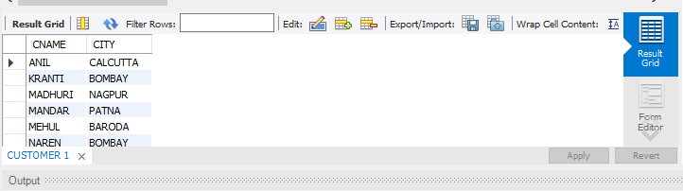**3.CUSTOMER TABLE**

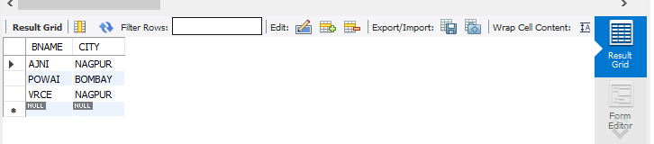**4. BRANCH TABLE**

**5. AMOUNT NO AND AMOUNT FROM DEPOSITE TABLE**

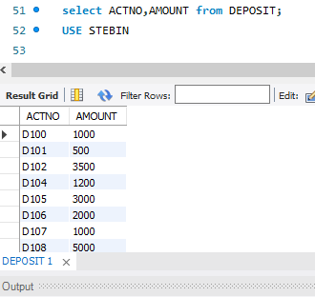

**6.GIVE CUSTOMER NAME AND ACCOUNT NO OF DEPOSITORS**

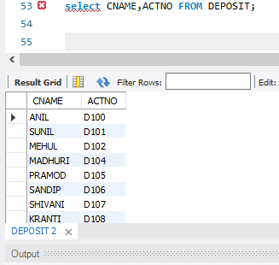

**7. NAME OF CUSTOMERS**

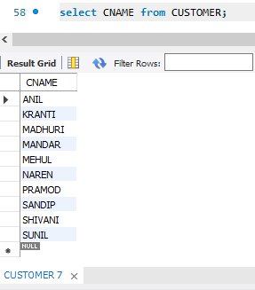

**8.NAME OF BRANCHES**

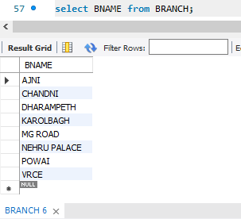

**9. NAME OF BORROWS**

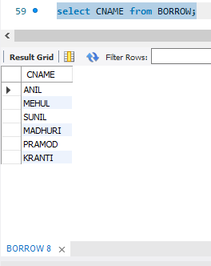

**10. NAME OF CUSTOMERS LIVING IN CITY NAGPUR**

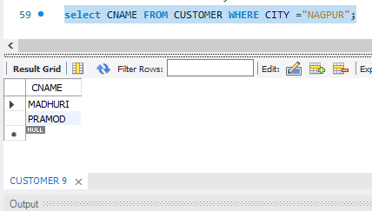

**11. NAMES OF DEPOSITORS HAVING AMMOUNT GREATER THAN 4000**

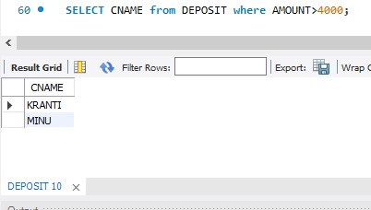

**12.ACCOUNT DATE OF ANIL**

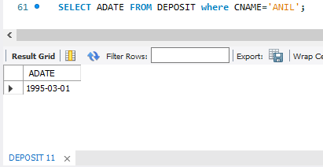

**13. NAME OF ALL BRANCHES LOCATED IN BOMBAY**

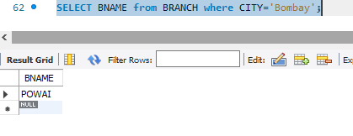

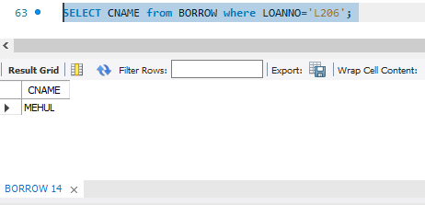**14. NAME OF BORROWER HAVING LOAN NUMBER 1206**

**15.NAME OF DEPOSITORS HAVING ACCOUNT AT VRCE**

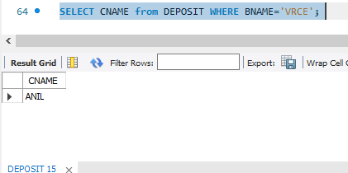

**16. NAMES OF ALL BRANCHED LOCATED IN CITY DELHI**

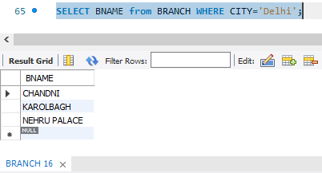

**17. NAME OF THE CUSTOMER WHO OPENED ACCOUNT DATE ‘4-1-96’**

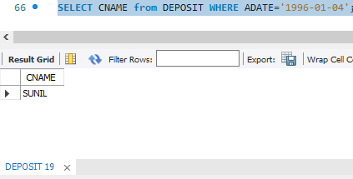

**18. ACCOUNT NO AND DEPOSIT AMOUNT OF CUSTOMER HAVING ACCOUNT OPENED BETWEEN DATES ‘12-1-96’ and ‘1-5-96’**

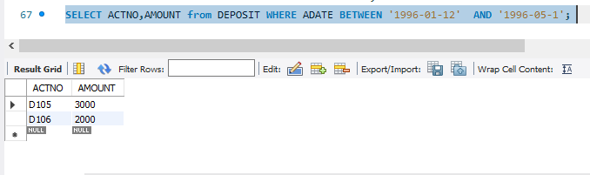

**19. NAME OF THE CITY WHERE BRANCH KAROLBAGH IS LOCATED**

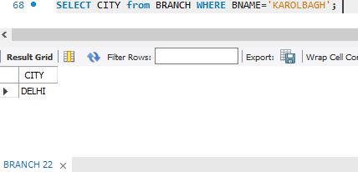

**20. DETAILS OF CUSTOMER ANIL**

